**November 2024 Newsletter**

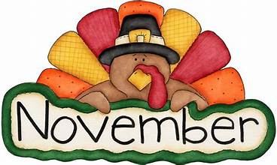Thank you to everyone for contributing items to our class last month. Your contributions are greatly appreciated and truly enhance our curriculum! We hope everyone had a safe and fun Halloween, we loved seeing all of the creative costumes!

This month we will be focusing on the themes called “My Imagination” and “Helpful Habitats”. Both of these units will challenge our Frogs to think creatively. Please donate any boxes you may have to our classroom, all sizes are appreciated especially shoe boxes! The color of the month is brown. If you have access to Spotify “Funshine Express has playlist paired with our curriculum called “Buttercups shapes and Colors” There is also “Fireflies Shapes and colors”. Feel free to play these songs at home with your child for some extended learning fun! The letter of the month is “F”. This month we will also emphasize hygiene and how we can work together to keep our shared spaces clean. Encouraging this practice at home will greatly help us continue to build our classroom community.

This month we will celebrate Olivia’s birthday on 11/9, Alina’s on 11/10, Pierce’s on 11/16, and Paisley’s on 11/29. We would also like to give a big Frog room welcome to our new friends Ariana, Emmett, and Lucy !